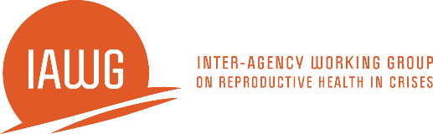

Uterine Evacuation in Crisis Settings Using Manual Vacuum Aspiration

Training Objectives

By the end of this training participants should be able to:
- Articulate their own comfort level discussing, advocating and providing uterine evacuation services;
- Explain what the current abortion law is in their setting and how it relates to what and how services are provided;
- Explain why uterine evacuation with manual vacuum aspiration (MVA) is an essential part of reproductive health services in crisis settings;
- Describe the various uterine evacuation options and explain why MVA is especially critical in crisis settings;
- Describe the safety, efficacy, and possible complications of MVA;
- Explain how medical abortion and misoprostol for incomplete abortion may be useful options for some women in crisis settings with MVA backup;
- Provide uterine evacuation method options counseling for women seeking uterine evacuation;
- Obtain informed consent prior to uterine evacuation;
- Describe the features of the MVA instrument and cannulae;
- Process MVA instruments in accordance with local regulations and with locally availably products/systems;
- Create a pain management plan with the woman that is sensitive to her situation;
- Describe the steps of providing uterine evacuation with Ipas MVA Plus®;
- Resolve common technical problems;
- Identify and explain to a woman how to recognize signs and symptoms of complications;
- Be able to simulate a UE procedure using Ipas MVA Plus® on a pelvic model;
- Discuss medical eligibility for select methods of postabortion contraception, including emergency contraction (EC);
- Provide referrals to other reproductive health services;
- Have an established plan to monitor the quality of on-site uterine evacuation services;
- Have an established plan to ensure sustainability of uterine evacuation and postabortion contraception services on site; and
- Understand and contribute towards a work plan to ensure the supply and resupply of instruments and related supplies, the sustainability of MVA services and ongoing training/mentoring needs.

