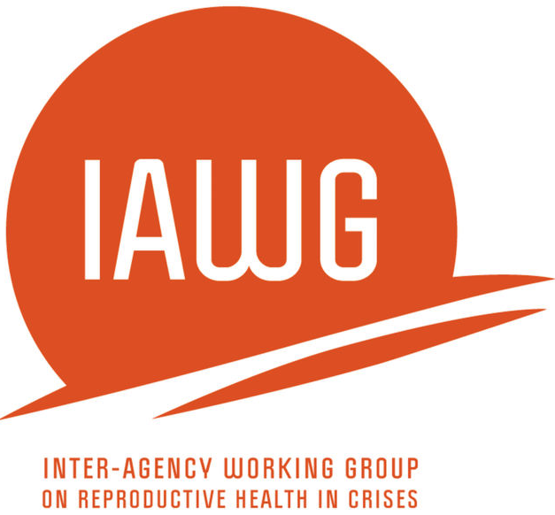
Focus Group Discussion - Tool

Men (18-24 years & 25-49 years)

MISP Process Evaluation

Introduction
Before commencing the focus group discussion, ensure informed consent is received. See Appendix E for a sample consent form.

“Hello, my name is_______________. I work for _______________. This is my team [introduce note-taker(s) and translator]. We are conducting a reproductive health assessment in this emergency in ______________. The purpose of this focus group is to find out more about integration of reproductive health into the humanitarian response and experiences in accessing the services. During the discussion, I will ask questions about your experiences in the reproductive health response and my colleague will write your answers down. We are holding discussions at a number of other communities as well. The answers you and others provide will be used to inform a report that might be published or presented in one or more public health forums. Your name will not be included in any documents or presentations but we may include the name of this location. There is no direct benefit to you being in this study. If you are uncomfortable with any of this, you are free to opt out of participating now or at any time during the discussion. You can also choose not to answer any of the questions. Please stop me at any time during the interview if you have questions or concerns. Should you have any questions or concerns about this study or your interview, please contact________________________. Is it ok to proceed?

Date:  Start/End Time (if available): | Location of FGD:  Please list the names of the area/s where participants live:  Country:
Focus group discussion facilitator:

Note-takers:

Translation used for interview: Yes No | If yes:  Translation from _____________________(language)  to _____________________________(language)
Number of participants in this group (total): | Important note regarding gender:  Given the discussion topic of these focus groups, it is recommended that women and men, boys and girls, are separated during focus group discussions.
Gender of FGD participants:

Males (specify number) ________

<18 years (specify number) _________
18-24 years (specify number) _________
25-49 years (specify number) _________
QUESTIONS
NOTES: The assessment team should review the questions for age-appropriateness in the context. In addition, although this is structured as a focus group discussion guide, the questions can be modified to fit other data collection methods that are identified as more appropriate such as an individual interview or use of participatory methods.

A. First we would like to ask you some general questions about the situation for refugee men in [location].
A1. What issues are of greatest concern among men within [location]?
A1a. What could be done to improve these particular issues?
A2. Please describe how organizations responding to this emergency have communicated with the affected community about services?
B. Next, we would like to ask you some general questions about health services in [location].
B1. From your knowledge, to what extent have men or men’s groups been involved in designing or delivering health services to meet their needs in [location]?
B2. What programs are available just for adolescents? [PROBE: have you ever visited a program/center that is specifically targeted for adolescents?]
B2a. What reproductive health services do these programs offer?
B3. What are some reasons why a man would not seek health services?
B3a. PROBE: any problems with clinic or hospital hours? providers? or medicines?
B4. Where do women seek health care when they are pregnant?

B4a. Where do women seek health care when they are giving birth?

B4b. Where do women seek health care after they give birth?
B5. How much do these services cost? [PROBE: What travel costs are there to get to the clinic or costs once at the clinic?]
B6. What have you heard about the quality of services for pregnant women and for giving birth?
B7. How long has each participant been here?
B7a. What services for pregnant women and for giving birth were available when you arrived?
B8. How did you learn about these services for pregnant women and for giving birth?
B9. What symptoms would cause women to seek help when they are pregnant? [Probe: What serious health problems relating to women’s experiences during pregnancy and childbirth have you seen since you arrived in this setting?]

B10. If a woman is having problems with the delivery of her infant, what can she do?

B10a. Where can she go to receive care?

B10b. How will she get there?

B10c. How can women receive care if they need assistance with a delivery at night, during a weekend or a holiday?

B10d. During childbirth, who do women seek help or assistance from in the community? For example, traditional birth attendants, traditional healers, or midwives.

B11. What are danger signs for health problems in a newborn baby?

B11a. Where can you take a baby to receive care for serious problems?

B11b. How can you get there?

B11c. How can you receive care at night, on a holiday or during the weekend?

B12. What are the breastfeeding practices in this community?

B12a. What changes in breastfeeding practices have there been after the crisis?
B13. What do men do in this society to prevent or postpone having babies?
B13a. Where do you find trusted sources of information about family planning?
B13b. What costs are there for these services?
B14. What do women do in this community if they are pregnant but do not want to be pregnant?
B15. Overall, how do you think health services for men and adolescent men within [location] could be improved?
C. Now I would like to talk about STIs/HIV/AIDS for a few minutes.
C1. What do you know about HIV/AIDS?
C2. What do people do to prevent HIV transmission?
C3. How do individuals that were taking HIV medicines (anti-retrovirals) before they fled, continue to receive treatment?
C4. Have you heard of any other diseases that you can get from having sex, for example, sexually transmitted infections (STIs)? (PROBE: Can you name any sexually transmitted infections [STIs]?)
C5. What would people do in this community if they thought they had a sexually transmitted infection (STI)?
C5a. What health services are there to use for treatment?
C5b. How did you learn about these health services?
C6. Where in this location can condoms can be found? [IF NO PLACES Q C6c]
C6a. Are the condoms free?
C6b. How have men learned about where these condoms can be found?
C6c. What barriers prevent access to condoms? (Probe: what can be done to make condoms more accessible?)

[***NOTE: Decide with GBV Working Group and local partner if asking about GBV in male FGD groups is appropriate. See Female FGD guide for questions on sexual violence. ***]
E. Before we finish, I would like to invite you to speak up if there anything about health care services, especially as it relates to reproductive health care or care for men or adolescent males, that we have missed and you would like to discuss.

We thank you for your time. You have all helped to provide a good understanding of the situation here. Your contributions are greatly appreciated. If you have any concerns, or think of additional information that should be shared, you can contact our organizations through the following contacts this week.
(Provide each participant with information about local contacts for complaints, concerns, or follow up)
**

NOTES from anecdotal conversations or additional notes:

Feedback Form
Please use this page as an opportunity to provide feedback on this tool. Consider introduction, length of time taken, wording and relevancy of questions, challenges with any questions, missing data, cultural sensitivity, changes made to questions during the pilot, form structure as well as other issues you would like to raise. Please be as specific and detailed as possible and feel free to add more pages. Please also write edits on the tool itself and scan and email the tool and the feedback form to Sandra Krause at sandrak@wrcommission.org.

