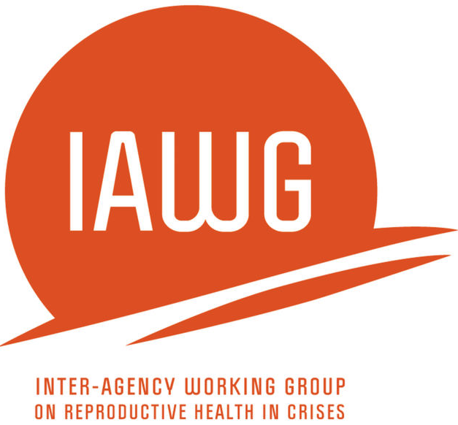
Focus Group Discussion – Indicator List

Men (18-24 years & 25-49 years)

MISP Process Evaluation

The objectives of the male FGD tool are to:
- Understand the main sexual and reproductive health concerns among beneficiaries.
- Explore beneficiaries’ knowledge and perceptions of MISP services.
- Gain insight on the availability of MISP services.
- Explore factors that influence the accessibility of MISP services.

Question | MISP Objective(s) | Indicator(s) | Comments
A. GENERAL QUESTIONS
A1. What issues are of greatest concern among men within [location]? | Overall RH response | Issues of greatest concern to men in this setting identified
A1a. What could be done to improve these particular issues? | Overall RH response | Men’s suggested solutions to issues of greatest concern to women identified
A2. Please describe how organizations responding to this emergency have communicated with the affected community about services. | Overall RH response | Men’s perceptions of responding agencies’ communication with the affected community documented
B. HEALTH SERVICE DELIVERY
B1. From your knowledge, to what extent have men or men’s groups been involved in designing or delivering health services to meet their needs in [location]? | Overall RH response | Number of men’s focus groups reporting men have been engaged in design/delivery of health services
B2. What programs are available just for adolescents? [PROBE: have you ever visited a program/center that is specifically targeted for adolescents?] | Overall RH response | Number of men’s focus groups reporting availability of adolescent specific programs  Number of men’s focus groups reporting having visited a youth program
B2a. What reproductive health services do these programs offer? | Overall RH response | Type of adolescent RH services offered documented
B3. What are some reasons why a man would not seek health services? | Overall RH response | Barriers to men seeking health services documented
B3a. PROBE: any problems with clinic or hospital hours? providers? or medicines? | Overall RH response, MISP Objectives 2-4 | Number of men’s focus groups reporting problems with:  Clinic/hospital hours  Providers  Medicines
B4. Where do women seek health care when they are pregnant? | MISP Objective 4 | Number of men’s focus groups reporting that women seek prenatal care at a health facility  Places/individuals women seek prenatal care from documented
B4a. Where do women seek health care when they are giving birth? | MISP Objective 4 | Number of men’s focus groups reporting that pregnant women give birth in health facility  Places/individuals women seek care from during delivery documented
B4b. Where do women seek health care after they give birth? | MISP Objective 4 | Number of men’s focus groups reporting that women seek post-natal care at a health facility  Places/individuals women seek post-natal care from documented
B5. How much do these services cost? [PROBE: What travel costs are there to get to the clinic or costs once at the clinic?] | MISP Objective 4 | Costs of child birth (including travel costs) documented
B6. What have you heard about the quality of services for pregnant women and for giving birth? | MISP Objective 4 | Number of men’s focus groups reporting availability of good quality maternal health services  Men’s perceptions of quality of maternal health services documented
B7. How long has each participant been here? | MISP Objective 4 | Length of time of displacement in current location – men
B7a. What services for pregnant women and for giving birth were available when you arrived? | MISP Objective 4 | Number of men’s focus groups reporting availability of maternal health services for pregnant women on their arrival  Maternal health services available on arrival documented
B8. How did you learn about these services for pregnant women and for giving birth? | MISP Objective 4 | Ways in which men learned about maternal health services documented
B9. What symptoms would cause women to seek help when they are pregnant? [Probe: What serious health problems relating to women’s experiences during pregnancy and childbirth have you since you arrived in this setting?] | MISP Objective 4 | Maternal health symptoms that would prompt women to seek help documented  Accounts of serious health maternal health problems documented
B10. If a woman is having problems with the delivery of her infant, what can she do? | MISP Objective 4 | Places/individuals women seek care from during problems with delivery documented
B10a. Where can she go to receive care? | MISP Objective 4 | Number of men’s focus groups reporting that women with problems during delivery can seek care at health facility
B10b. How will she get there? | MISP Objective 4 | Number of men’s focus groups reporting availability of transport system for obstetric emergencies
B10c. How can women receive care if they need assistance with a delivery at night, during a weekend or a holiday? | MISP Objective 4 | Number of men’s focus groups reporting availability of transport system for obstetric emergencies 24 hours a day, 7 days a week
B10d. During childbirth, who do women seek help or assistance from in the community? For example, traditional birth attendants, traditional healers, or midwives. | MISP Objective 4 | Number of men’s focus groups reporting that women in childbirth seek help from:  TBAs  Traditional healers  Midwives  Other (specify)
B11. What are danger signs for health problems in a newborn baby? | MISP Objective 4 | Number of men’s focus groups able to accurately identify danger signs for newborn babies
B11a. Where can you take a baby to receive care for serious problems? | MISP Objective 4 | Number of men’s focus groups reporting availability of facility-based care for newborns with medical problems  Places/individuals where the community can bring a newborn experiencing problems
B11b. How can you get there? | MISP Objective 4 | Number of men’s focus groups reporting transport available for newborn emergencies
B11c. How can you receive care at night, on a holiday or during the weekend? | MISP Objective 4 | Number of men’s focus groups reporting 24/7 transport available for newborn emergencies
B12. What are the breastfeeding practices in this community? | MISP Objective 4 | Breastfeeding practices documented
B12a. What changes in breastfeeding practices have there been after the crisis? | MISP Objective 4 | Changes in breastfeeding practices after the crisis documented
B13. What do men do in this society to prevent or postpone having babies? | Additional Priority – Contraceptives | Number of men’s focus groups reporting men use modern contraceptives  Community practices to prevent/postpone pregnancy documented
B13a. Where do you find trusted sources of information about family planning? | Additional Priority – Contraceptives | Number of men’s focus groups reporting the following trusted sources of information about family planning:  MOH  Aid agencies (NGOs, UN)  TBAs  Other (specify)______  Unknown
B13b. What costs are there for these services? | Additional Priority – Contraceptives | Cost of birth control related services documented
B14. What do women do in this community if they are pregnant but do not want to be pregnant? | MISP Objective 4, Additional Priority – Contraceptives | Number of men’s focus groups reporting that women who wish to terminate their pregnancy use:  Safe abortion  Unsafe abortion/traditional  methods (specify)  Other (specify)  Nothing
B15. Overall, how do you think health services for men and adolescent men within [location] could be improved? | Overall RH response | Men’s suggestions for improving RH services for men and adolescent men documented
C. STIs/HIV/AIDS
C1. What do you know about HIV/AIDS? | MISP Objective 3 | Number of men’s focus groups who have basic knowledge of HIV/AIDS  Men’s knowledge of/attitudes towards HIV/AIDS documented
C2. What do people do to prevent HIV Transmission? | MISP Objective 3 | Number of men’s focus groups able to accurately identify at least one form of prevention for HIV transmission  Community practices related to HIV prevention documented
C3. How do individuals that were taking HIV medicines (anti-retrovirals) before they fled, continue to receive treatment? | MISP Objective 3, Additional Priority - ARVs | Number of men’s focus groups reporting that individuals on ARVs have been able to continue treatment
C4. Have you heard of any other diseases that you can get from having sex, for example, sexually transmitted infections (STIs)? (PROBE: Can you name any sexually transmitted infections [STIs]?) | Additional Priority - STIs | Number of men’s focus groups able to name at least one STI
C5. What would people do in this community if they thought they had a sexually transmitted infection (STI)? | Additional Priority - STIs | Number of men’s focus groups reporting that people would seek health services if they thought they had an STI
C5a. What health services are there to use for treatment? | Additional Priority - STIs | Number of men’s focus groups reporting at least one health service available for STI treatment
C5b. How did you learn about these health services? | Additional Priority - STIs | Ways in which men learned about STI treatment services documented
C6. Where in this location can condoms be found? | MISP Objective 3, Additional Priority - Contraceptives | Number of men’s focus groups reporting at least one location where condoms are available
C6a. Are the condoms free? | MISP Objective 3, Additional Priority - Contraceptives | Number of men’s focus groups reporting condoms are freely available at least one location
C6b. How have men learned about where to find condoms? | MISP Objective 3, Additional Priority - Contraceptives response | Ways in which men have learned of condom availability documented
C6c. What barriers prevent access to condoms? (Probe: what can be done to make condoms more accessible?) | MISP Objective 3, Additional Priority - Contraceptives | Barriers to condom accessibility documented  Ways to improve condom accessibility documented
E. I would like to invite you to speak up if there anything about health care services, especially as it relates to reproductive health care or care for men or adolescent males, that we have missed and you would like to discuss.
[***NOTE: Decide with GBV Working Group and local partner if asking about GBV in male FGD groups is appropriate. See Female FGD guide for questions on sexual violence. ***]

