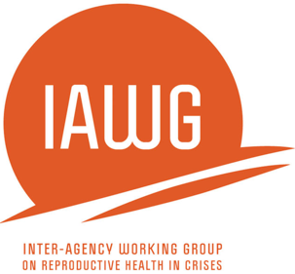
Sample Consent Form for Focus Group Participants
MISP Process Evaluation

Hello, my name is_______________. I work for _______________. We are conducting a reproductive health assessment in this emergency in ______________. The purpose of this focus group is to find out more about integration of reproductive health into the humanitarian response and experiences in accessing the services. During the discussion, I will ask questions about your experiences in the reproductive health response and my colleague will write your answers down. We are holding discussions at a number of other communities as well. The answers you and others provide will be used to inform a report that might be published or presented in one or more public health forums. Your name will not be included in any documents or presentations but we may include the name of this location. There is no direct benefit to you being in this study. If you are uncomfortable with any of this, you are free to opt out of participating now or at any time during the discussion. You can also choose not to answer any of the questions. Please stop me at any time during the interview if you have questions or concerns. Should you have any questions or concerns about this study or your interview, please contact________________________.

Is it ok to proceed?

Verbal Consent

Date: ___________________________ (dd/mm/yyyy) Location:_________________________________

Type of FGD (gender, age range, etc):_________________________________

Was verbal consent obtained? Yes No _________________________ (Signature of data collector)

Written Consent Form

Participant Name: _______________________________

Date: ___________________________ (dd/mm/yyyy)

Location:_________________________________

I understand the MISP process evaluation. I understand that consent to participate in the evaluation means giving consent to have the information I share during the focus group be used, without my name, in the evaluation and published in evaluation documents and reports. I have understood all that I have read/has been read and explained to me. I have been given sufficient information and have had my questions answered satisfactorily. I understand that my participation in this interview is entirely voluntary and I will receive no benefits for my participation.

I agree to participate in the Process Evaluation of the MISP for Reproductive Health.

Signature: ___________________________ Date: ________________ Time: _______am/pm

