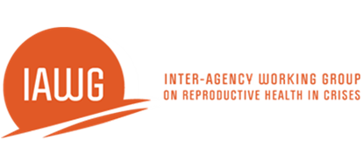
Course Evaluation: Assisted Vaginal Delivery via Vacuum Extraction
Date: Location: _______
Please fill out the following course evaluation to help us improve upon the course in the future. Thank you for your feedback.
- What is your gender?
  - Female
  - Male

- How old are you?
  - <30
  - 30-39
  - 40-49
  - >50

- What is your job title?
  - Doctor
  - Nurse
  - Midwife
  - Health Officer
  - Other

- Have you ever received training in using vacuum extraction for assisted vaginal delivery?
  - Yes
  - No

- How many vaginal deliveries have you performed in the past month?
  - 0
  - 1-10
  - 11-20
  - 30+

- How many assisted vaginal deliveries have you performed using vacuum extraction or forceps in the past 6 months?
  - 0
  - 1
  - 2
  - 3 or more
<continued>

Course Evaluation: Assisted Vaginal Delivery via Vacuum Extraction
7. Please fill out the table below regarding your impressions of the course.
4 = strongly agree 3= agree 2= disagree 1= strongly disagree
Questions: | Rating | Comments
1. The course fulfilled its goal and objectives.
2. The course content was useful and relevant to my needs.
3. The course content was organized with enough time for each unit/activity.
4. The topic was appropriate to my level of knowledge.
5. What is your overall impression of the course? | N/A

8. Please list 3 things that need to be improved in the course

9. Now that I have completed this course, I feel
- Ready to offer care to women with vacuum extraction.
- That this procedure is not one I would choose to provide.
- Prepared to promote (but not provide) vacuum extraction.
- Other (please describe)_______________________________________________________

Thank you!

